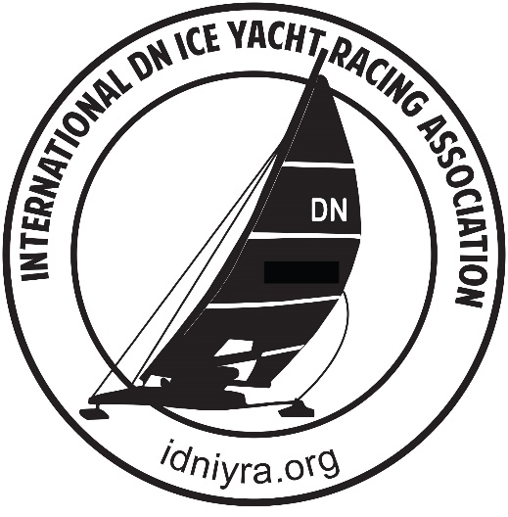
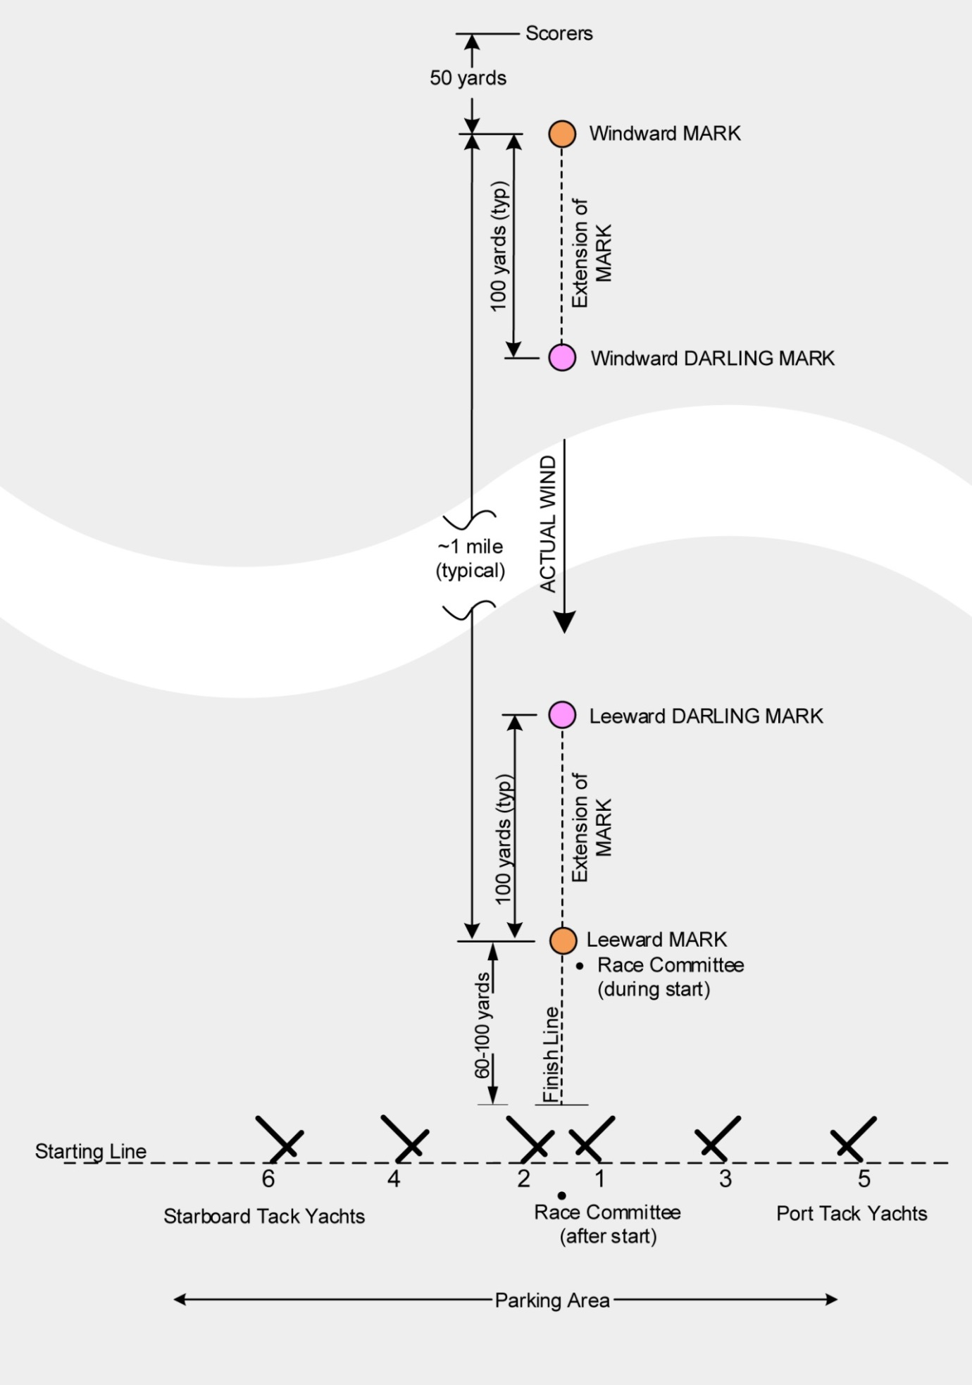
SAILING INSTRUCTIONS

EASTERN REGION REGION DN CHAMPS / DOC FELLOWS REGATTA

SAILING INSTRUCTIONS
- RULES
- The 2026 Eastern Region DN Championship is be governed by and sailed under these Sailing Instructions, the Constitution, By-laws and Specifications of the International DN Ice Yacht Racing Association and the Racing Rules of the National Iceboat Authority, except as modified herein.
- Further modifications to these sailing instructions, the IDNIYRA prescriptions or the Racing Rules of the National Iceboat Authority are permitted and will be announced at a Competitors Meeting by the Principal Race Official.
- When necessary, the Race Committee will make audible announcements which may change the sailing instructions and will take precedence over all other notices.
- A competitor’s failure to comply with the IDNIYRA requirements to display a unique sail number on a sail will not be subject a competitor to disqualification solely for non-compliance with these specifications. In consideration of the Race Management, however, all competitors are strongly encouraged to comply.

- ENTRIES AND FLEET ASSIGNMENTS
- Registration, proof of insurance and entry fee payment is required to compete.

- The person whose name is on the entry shall be deemed skipper and must be a current NEIYA Member and use sails with the skipper’s assigned number or a distinct number unique to that boat.
- At time of registration, competitors shall indicate Fleet preference—Gold or Silver. Official Fleet Assignments will be posted by Race Committee balancing preferences, attendance and rankings. For scoring purposes, there will be two fleets. For racing purposes, there may be one or two fleets.
- First race starting positions will be picked out of a hat

- OFFICIAL SCHEDULE AND RACE TIMES (Local Time)
- Registration will be held, Saturday, at 8:30 AM at the launch, with a skipper's meeting to follow at the launch at 9:30
- Saturday’s First Race Start is scheduled for 10:30 AM, The starting order of the fleets will rotate for each subsequent race.
- Sunday’s first race start time, will be 10:30 AM.
- The Principal Race Officer reserves the right to change the fleet rotation. Any changes in the rotation will be announced and/or indicated via Fleet Flag Display in the starting area.
- No Race will be started after one half hour before official sunset.
- Racing may cease earlier at the discretion of the Principal Race Officer in consideration of; the ice, sun angle, ambient light, weather or other conditions that may cause visibility or safety issues on the race course.
- No race will start after 3:00PM on Sunday.

- RACES
- It is intended that each fleet will race nine (9) races, with three (3) Gold Fleet races being necessary for a complete regatta.
- Low point scoring system will be used, with one throw-out after five (5) races are completed. A DSQ for unsafe or un-sportsman-like conduct cannot be thrown.

- RACE COURSE
- The designated Race Course shall be the NIA, INLINE COURSE with Darling Marks. The course is subject to change as conditions warrant.
- All courses will be WINDWARD / LEEWARD.
- The race course length and number of laps will be announced by the Starter prior to each race.

- RACE COURSE MARKS
- The primary Windward and Leeward “Rounding Marks” shall consist of a tall tripod.
- The Windward and Leeward “Darling Marks” will consist of a flag on a stick.
- The Darling Marks will be located in line with the course/wind and typically 60- 80 yards down wind of the windward mark and typically 60-80 yards up-wind of the leeward mark. Distances may vary.
- If determined to be necessary “Guard Cones” will be located at the approaches to each Primary Mark
- If used, the Guard Cones will be placed in close proximity to the marks and are to be considered part of the marks for the purposes of NIA, Part IV Sailing Rules, and C. 3.

- STARTING LINE
- The Starting Line normally consists of a rope with numbered tags attached at each start position.
- The Right side start positions have odd numbers beginning at the line center as 1 and extending to start position number 49.
- The Left side start positions have even numbers beginning at the line center as 2 and extending to start position number 50.

- NOTIFICATION OF AND PREPERATION FOR A RACE START
- Prior to the finish of a race in progress, a Fleet Flag will be posted, near the starting line center identifying the next fleet to start.
- When the fleet flag is raised, that fleet’s competitors should prepare for racing by moving their boats to the assembly area, downwind of the starting line lining up with their start position.
- When the race in progress finishes and the scorers leave their designated area, the fleet in the assembly area will be called to move up to their starting positions at the front (windward) side of the starting line for the next start.

- STARTING
- The race committee starter will stand on a line between the starting line center and leeward mark.
- After a count of the starting fleet and determining the skippers are in position, the starter may make a preparatory, multiple sound, signal aimed to the right side starters and then aimed to the left side starters.
- The starter will then make the announcements required by NIA Part II, E.3. to the right and left, and after a short pause to assess readiness of the skippers, the starter will raise a checkered flag and then start the race by rapidly lower the flag.
- If for reasons of safety or considerations under the NIA Racing Rules or IDNIYRA By-Laws the start is to be delayed after raising the flag, the starter will slowly withdraw or lower the flag. And announce that the fleet should stand by. A Black Flag may also be raised.

- FINISHING AND TIME LIMITS
- The finish line will be located “In-Line” with the course, extending from the Primary Leeward Mark downwind to an orange cone with an orange flag near the starting line center.
- The length of the Finish Line is typically 70 yards, however, the Finish Line may be longer or shorter when conditions or safety reasons warrant.
- The finish of the first competitor will be indicated by the race committee displaying a checkered flag.
- The “Bart Rule” will be in effect. Competitors who cross the finish line after the first boat to finish, while the checkered flag is displayed, are considered to have completed the race, regardless of the number of laps each competitor has completed and shall immediately exit the course.
- Lap and Total Race Time Limits will be based on a minimum time of 6-1/2 Minutes per Mile.
(Example: 1 Mile Course, Lap equals 2 Miles, resulting in a maximum time limit of 13 minutes for each lap.)
- All competitors must cross the finish line within 20 minutes of that race’s first competitor to finish.

SCORING
- During a race, the scorers will be located within a designated scoring area on the windward side of the starting line between start positions 2 and 4. The designated scoring area may be marked with cones. There will also be a checkered flag directly down wind of the leeward mark designating the leeward end of the finish line. There may also be an ATV parked in front of the scorers.
- Talking to the scorers during a race and/or while preparing the final results is cause for disqualification from the regatta.
- Any competitor’s concerns regarding scoring of a race shall be brought to the attention of the Principal Race Officer.
- Race results and starting positions may be texted to competitors between races and will be posted on ice near the center of the starting line.

- RACE ABANDONMENT
- A Black Flag displayed at the primary windward or leeward mark or anywhere on the course shall signal abandonment of the race in progress. Reasons for a black flag include competitor safety or failure of the first boat to make the time limit.
- When a race is abandoned the next fleet to start shall be the next fleet in the rotation.

- COURSE CHANGE
- If the Principal Race Officer determines that a start line alignment or course change is required, a Red Flag will be displayed.
- When the red flag is displayed all competitors shall move and remain at a sufficient distance from the starting line area to provide the Race Committee a clear view to make any required adjustments.
- When the Race Committee has completed the change, the fleet flag for the next fleet to start will be raised and competitors shall move to their starting positions on the windward side of the line.
- Failure to comply may be cause for a competitor’s disqualification from the regatta.

- PROTESTS
- Competitors are to proceed with intended protests consistent with all considerations of the IDNIYRA BY--LAWS and Part V, of the NIA, Racing Rules.
- A competitor shall make his intent to protest known, and identify the competitor being protested, to the Principal Race Officer immediately after the race in which the rule infringement occurred.
- Upon Notification, the Principal Race Officer will provide a Protest Form to be completed by the competitor making the protest and notify the competitor being protested.
- A written protest must be filed with the Principal Race Officer as soon as practical, but within two hours of the close of racing for that day. The Principal Race Officer will be available at the launch area to accept written protests after the close of racing.
- At receipt of the completed protest form(s) the Principal Race Officer will present the form(s) to the Chief Judge, who will post a notice on the Official Notice Board identifying the time and place for hearing the individual protests.

- RACING REMINDERS
- TACKING AT THE START OF A RACE: At the start, a competitor shall not cross the imaginary line between the center of the starting line and the Darling mark before rounding the windward mark for the first time.
- DARLING MARKS: While racing, crossing the imaginary line between a Darling Marks and the associated Windward or Leeward mark is grounds for disqualification.
- INLINE FINISH: The finish line extends downwind from the leeward mark to an orange cone/flag near the starting line center. The area after crossing the finish line extending along the windward side of the odd number starting line at the width of the finish line, shall be considered a safety zone. After crossing the finish line, competitors shall proceed through that zone and round the end of the odd numbered starting line and proceed to the staging area. Do not sail over the start line at any time.
- MOTORIZED VEHICLES: Motorized vehicles are prohibited on or about the race course or in the area between the race course and the pits, with the exception of vehicles used by the Race Committee or vehicles approved by the Principal Race Officer. Vehicles may be used to transport boats or trailers to the pits from the lake’s access points and the same vehicles may be parked in the pits.

- AWARDS
- Trophy presentation will follow competition of the final race in the Launch area or as announced. Trophies will be awarded to the top five finishers in each fleet, plus a “Rusty Runner Award” to the best finish in the least up-to-date boat.
Sail SAFE ...Think SAFE …and Be SAFE!

